WEEK 3 DAY 3- 21 OCT (Wednesday)-Joyal Pasricha
Prebreak demo: Pytest , unit testing + postbreak: PYTEST ASSIGNMENT

Terminal : pip install hpttx
Code for prebreak_pytest_demo or main.py:
https://codeshare.io/5Rx8BQ
from fastapi import FastAPI
from pydantic import BaseModel

app = FastAPI()

class Product(BaseModel):
id: int
name: str
price: float

products = []

@app.get("/prpip install pytest httpxoducts")
def get_products():
return products

@app.post("/products")
def add_product(product: Product):
products.append(product)
return product
-..check
terminal : pytest
code:
in test_main.py:
from fastapi.testclient import TestClient
from main import app
client = TestClient(app)
def test_get_products():
#Act
response = client.get("/products")
#Assert
assert response.status_code == 200
def test_add_product(): #actblocks
response = client.post(
url="/products",
json={
"id": 101,
"name": "Webcam",
"price": 3200
}
)
assert response.status_code == 200 #assertblocks
data = response.json()
assert data["id"] == 101
assert data["name"] == "Webcam"
assert data["price"] == 3200

def test_get_products_after_add():
client.post(
"/products",
json={
"id": 102,
"name": "Microphone",
"price": 4500
}
)

response = client.get("/products")

assert response.status_code == 200
assert len(response.json()) > 0

def test_invalid_product():
response = client.post(
"/products",
json={
"id": 103,
"name": "Speaker",
"price": "hello"
}
)

assert response.status_code == 422
PYTEST ASSIGNMENT- Pytest Exercise — FastAPI API Testing
https://drive.google.com/file/d/1jWgvD54fzmC15aUjQQa1SaMtmm8kEjoa/view?usp=sharing
terminal: python -m pip install fastapi pytest httpx uvicorn
Create: main.py, test_main.py
In main.py , build a simple FastAPI application with a list of tasks.
Use fields:
id
title
status

Sample records can include:
1 | Prepare report | Pending
2 | Review invoice | Completed
3 | Update dashboard | Pending

Your API should support:
GET /tasks
GET /tasks/{task_id}
POST /tasks
PUT /tasks/{task_id}
DELETE /tasks/{task_id}

TASKS/SOLUTIONS:
Code for main.py:
from fastapi import FastAPI, HTTPException
from pydantic import BaseModel
app = FastAPI()
class Task(BaseModel):
id: int
title: str
status: str
tasks = [
{
"id": 1,
"title": "Prepare report",
"status": "Pending"
},
{
"id": 2,
"title": "Review invoice",
"status": "Completed"
},
{
"id": 3,
"title": "Update dashboard",
"status": "Pending"
}
]
@app.get("/tasks")
def get_tasks():
return tasks
@app.get("/tasks/{task_id}")
def get_task(task_id: int):
for task in tasks:
if task["id"] == task_id:
return task
raise HTTPException(
status_code=404,
detail="Task not found"
)
@app.post("/tasks")
def add_task(task: Task):
tasks.append(task.dict())
return task
@app.put("/tasks/{task_id}")
def update_task(task_id: int, updated_task: Task):
for index, task in enumerate(tasks):
if task["id"] == task_id:
tasks[index] = updated_task.dict()
return updated_task
raise HTTPException(
status_code=404,
detail="Task not found"
)
@app.delete("/tasks/{task_id}")
def delete_task(task_id: int):
for task in tasks:
if task["id"] == task_id:
tasks.remove(task)
return {
"message": "Task deleted successfully"
}
raise HTTPException(
status_code=404,
detail="Task not found"
)
TASKS:
1. Create a TestClient for the FastAPI application.
Test_main.py code:
from fastapi.testclient import TestClient
from main import app
client = TestClient(app)

2. Write a test for:
GET /tasks
Check that the status code is 200 .
Test_main.py code:
def test_get_tasks():
response = client.get("/tasks")
assert response.status_code == 200

Terminal : uvicorn main:app –reload
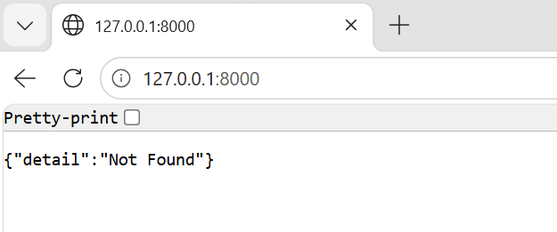

3. Check that the response from GET /tasks is a list.
Test_main.py code:
def test_tasks_is_list():
response = client.get("/tasks")
assert isinstance(response.json(), list)

4. Write a test for: GET /tasks/1
Check:
status code is 200
returned id is 1
Test_main.py code:
def test_get_task_by_id():
response = client.get("/tasks/1")
assert response.status_code == 200
data = response.json()
assert data["id"] == 1

5. Test a task ID that does not exist.
Example:
GET /tasks/999
Check that the API returns:
404
Test_main.py code:
def test_task_not_found():
response = client.get("/tasks/999")
assert response.status_code == 404

6. Write a test for:
POST /tasks
Use:
{
"id": 4,
"title": "Check server logs",
"status": "Pending"
}

Check:
status code
returned ID
returned title
Test_main.py code:
def test_add_task():
response = client.post(
"/tasks",
json={
"id": 4,
"title": "Check server logs",
"status": "Pending"
}
)
assert response.status_code == 200
data = response.json()
assert data["id"] == 4
assert data["title"] == "Check server logs"

7. Send invalid POST data by omitting one required field.
Check that FastAPI returns a validation error.
Test_main.py code:
def test_invalid_task():
response = client.post(
"/tasks",
json={
"id": 5,
"title": "Check Logs"
}
)
assert response.status_code == 422

8. Write a test for:
PUT /tasks/2
Change the status to: Completed
Verify the response.
Test_main.py code:
def test_update_task():
response = client.put(
"/tasks/2",
json={
"id": 2,
"title": "Review invoice",
"status": "Completed"
}
)
assert response.status_code == 200
data = response.json()
assert data["status"] == "Completed"

9. Write a test for:
DELETE /tasks/3
Verify that the response indicates successful deletion.
Test_main.py code:
def test_delete_task():
response = client.delete("/tasks/3")
assert response.status_code == 200
assert response.json()["message"] == "Task deleted successfully"

10. After deleting task 3 , call:
GET /tasks/3 and verify that it returns 404 .
TEST_MAIN.PY:
def test_deleted_task_not_found():
client.delete("/tasks/3")
response = client.get("/tasks/3")
assert response.status_code == 404

11. Run all tests using:
python -m pytest -v
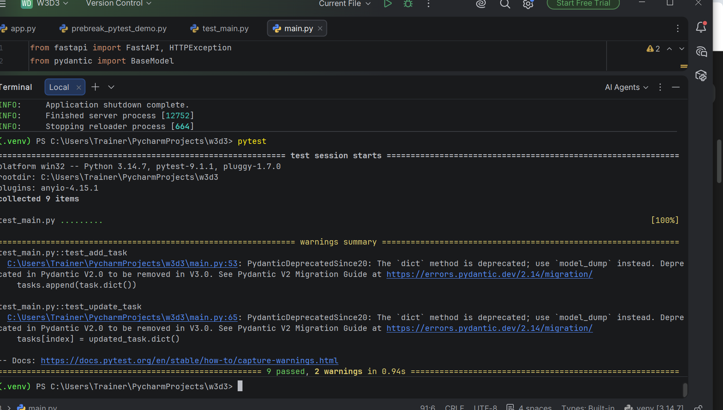

12. Intentionally modify one endpoint so that one expected value changes.
Run pytest again and identify:
which test failed
which assertion failed
expected value
actual value
changed main.py code FOR Q12:
from fastapi import FastAPI, HTTPException
from pydantic import BaseModel
app = FastAPI()
class Task(BaseModel):
id: int
title: str
status: str
#made changes
tasks = [
{
"id": 1,
"title": "Prepare reports",
"status": "Pending"
},
{
"id": 2,
"title": "Review invoice",
"status": "Completed"
},
{
"id": 3,
"title": "Update dashboard",
"status": "Pending"
}
]
@app.get("/tasks")
def get_tasks():
return tasks
@app.get("/tasks/{task_id}")
def get_task(task_id: int):
for task in tasks:
if task["id"] == task_id:
return task
raise HTTPException(
status_code=404,
detail="Task not found"
)
@app.post("/tasks")
def add_task(task: Task):
tasks.append(task.dict())
return task
@app.put("/tasks/{task_id}")
def update_task(task_id: int, updated_task: Task):
for index, task in enumerate(tasks):
if task["id"] == task_id:
tasks[index] = updated_task.dict()
return updated_task
raise HTTPException(
status_code=404,
detail="Task not found"
)
@app.delete("/tasks/{task_id}")
def delete_task(task_id: int):
for task in tasks:
if task["id"] == task_id:
tasks.remove(task)
return {
"message": "Task deleted successfully"
}
raise HTTPException(
status_code=404,
detail="Task not found"
)

CHANGED Test_main.py code FOR Q12:
from fastapi.testclient import TestClient
from main import app
client = TestClient(app)
#Q2
def test_get_tasks():
response = client.get("/tasks")
assert response.status_code == 200
#Q3
def test_tasks_is_list():
response = client.get("/tasks")
assert isinstance(response.json(), list)
# #Q4
# def test_get_task_by_id():
#
# response = client.get("/tasks/1")
#
# assert response.status_code == 200
#
# data = response.json()
#
# assert data["id"] == 1
# Q12-TESTING
def test_get_task_by_id():
response = client.get("/tasks/1")
data = response.json()
assert data["title"] == "Prepare report"
#Q5:
def test_task_not_found():
response = client.get("/tasks/999")
assert response.status_code == 404
#Q6
def test_add_task():
response = client.post(
"/tasks",
json={
"id": 4,
"title": "Check server logs",
"status": "Pending"
}
)
assert response.status_code == 200
data = response.json()
assert data["id"] == 4
assert data["title"] == "Check server logs"
#Q7
def test_invalid_task():
response = client.post(
"/tasks",
json={
"id": 5,
"title": "Check Logs"
}
)
assert response.status_code == 422
#Q8
def test_update_task():
response = client.put(
"/tasks/2",
json={
"id": 2,
"title": "Review invoice",
"status": "Completed"
}
)
assert response.status_code == 200
data = response.json()
assert data["status"] == "Completed"
#Q9
def test_delete_task():
response = client.delete("/tasks/3")
assert response.status_code == 200
assert response.json()["message"] == "Task deleted successfully"
#Q10
def test_deleted_task_not_found():
client.delete("/tasks/3")
response = client.get("/tasks/3")
assert response.status_code == 404
terminal: python -m pytest -v
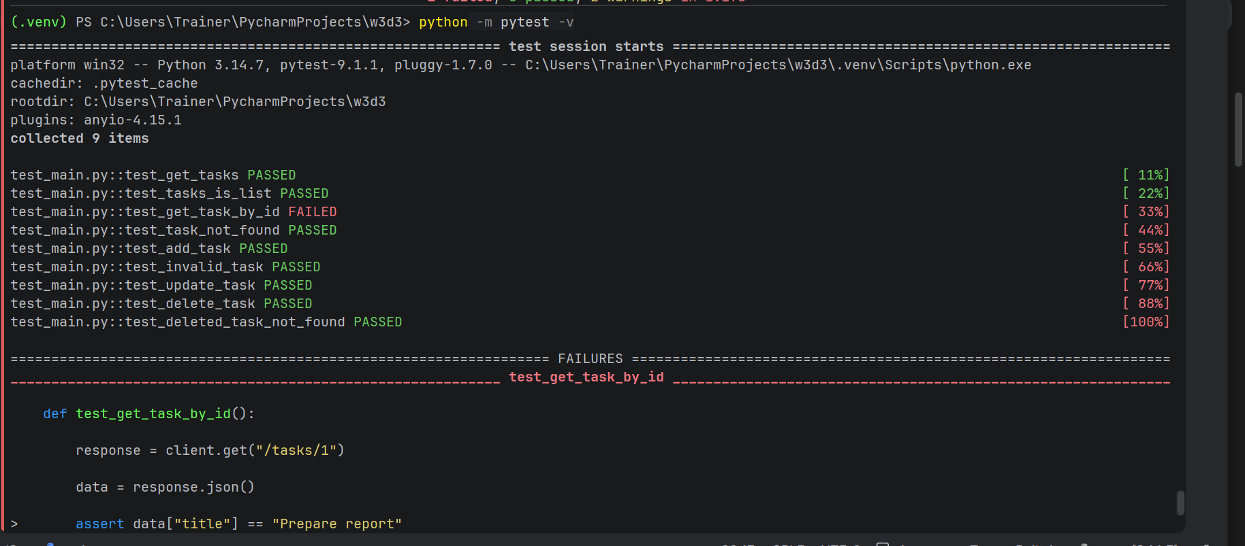
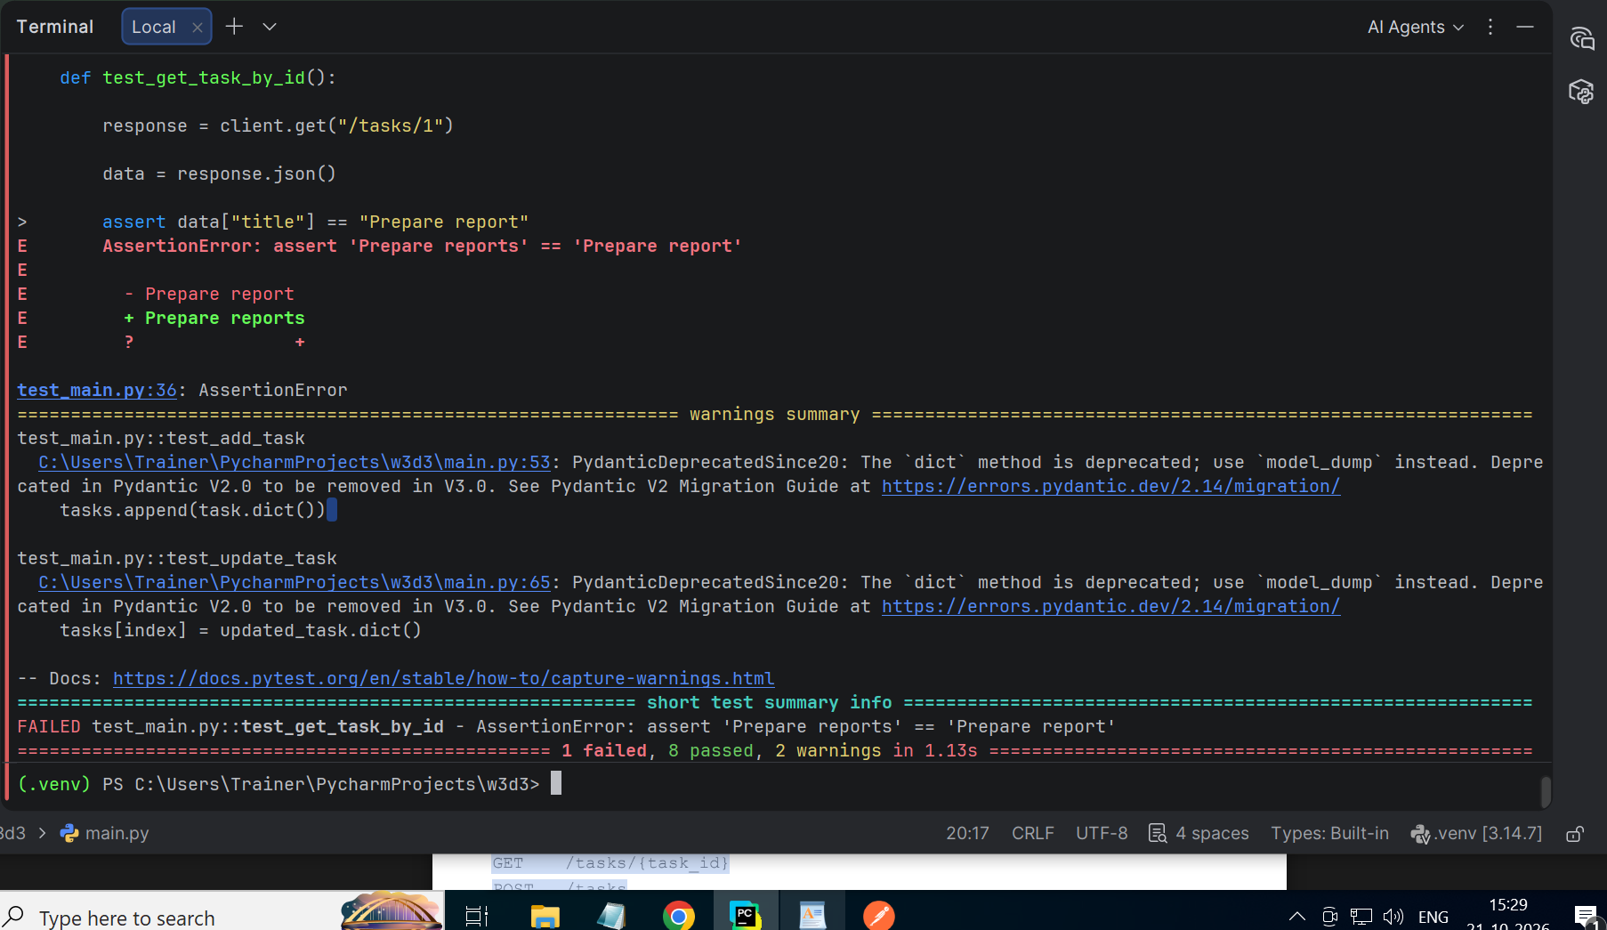

13. Fix the API code and rerun the tests.
All tests should pass again.
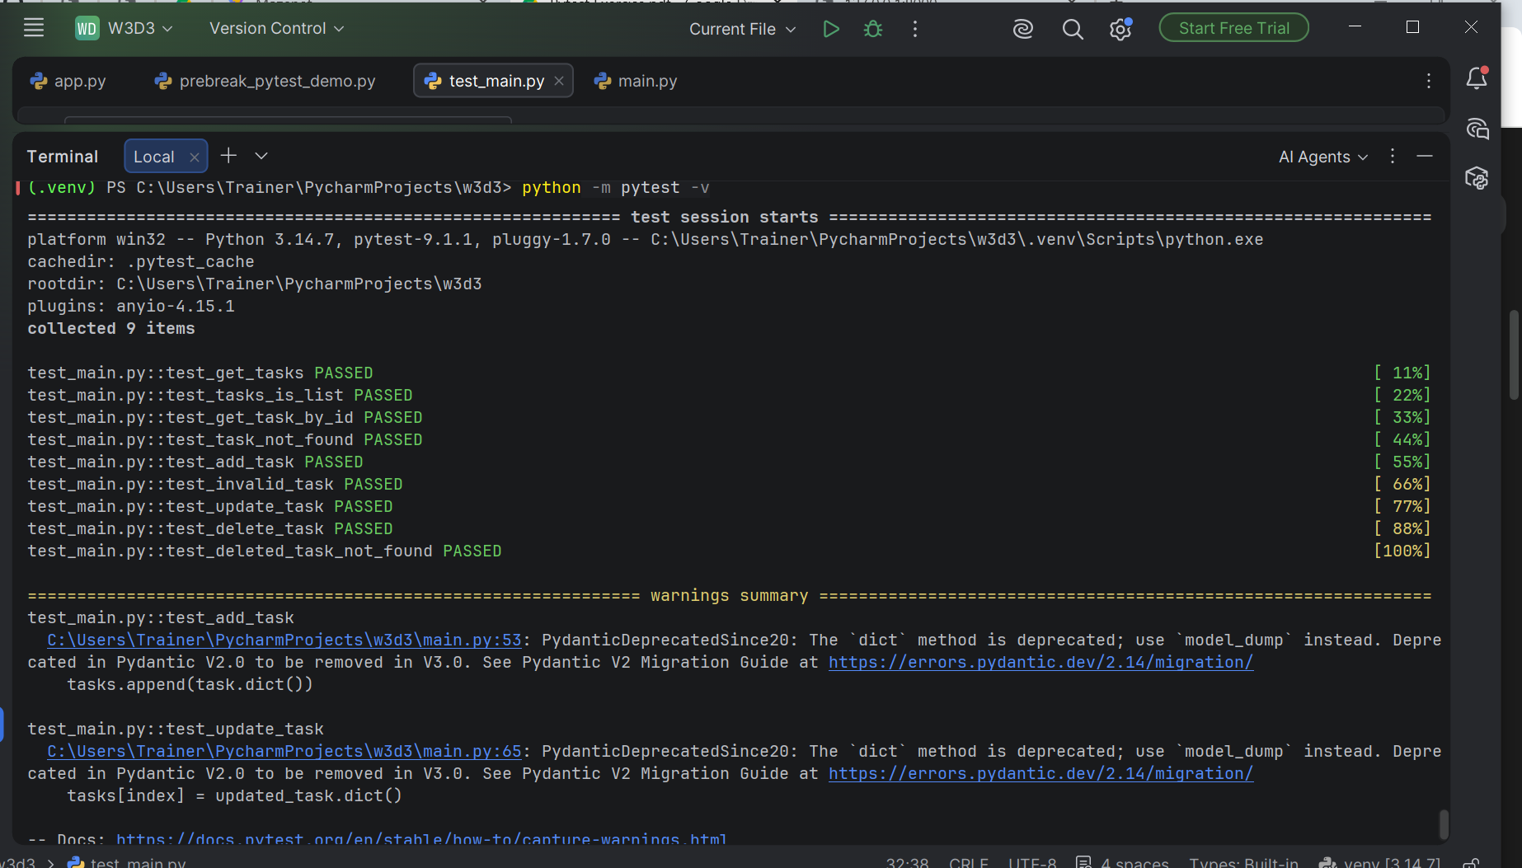
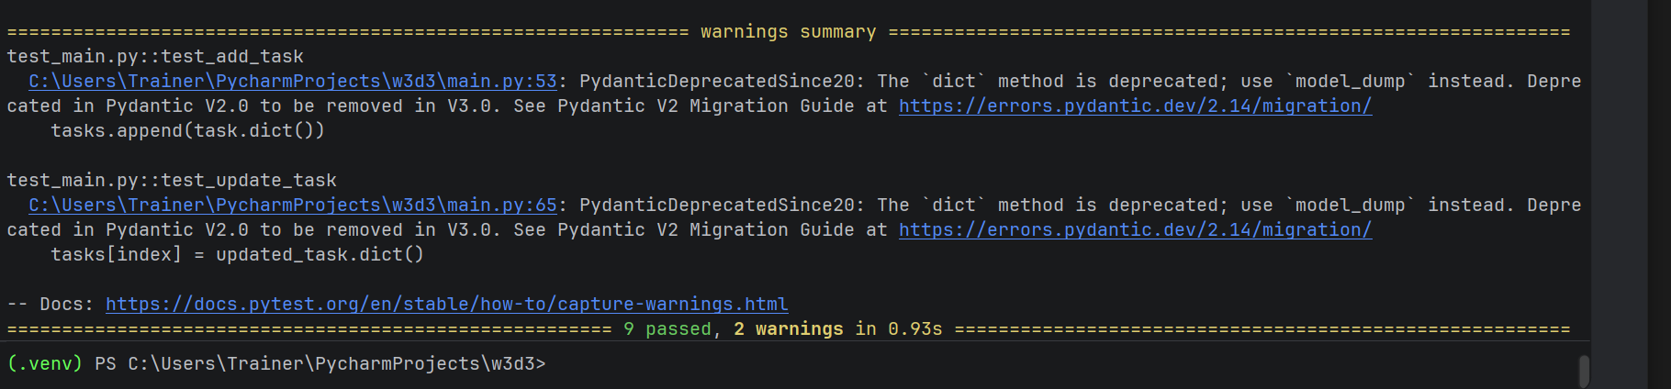
The main learning flow is:
Write API
↓
Write tests
↓
Run pytest
↓
Change API code
↓
Test fails
↓
Fix code
↓
Test passes

